A
Special Project Report
on

“VIRTUAL SOC LAB: SURICATA IDS INTEGRATED WITH ELASTIC SIEM STACK”

by
Arihant Dalai (23STUCHH011345)

Under the guidance of
Dr. Jangam Ebenezer


Faculty of Science & Technology,
The ICFAI Foundation for Higher Education, Hyderabad
April, 2026


Faculty of Science & Technology
The ICFAI Foundation for Higher Education Hyderabad

CERTIFICATE

This is to certify that the project entitled “VIRTUAL SOC LAB: SURICATA IDS INTEGRATED WITH ELASTIC SIEM STACK” by Arihant Dalai (23STUCHH011345) has been submitted in the partial fulfilment of the requirements for the award of degree of Bachelor of technology in computer Science and Engineering from Faculty of Science & Technology (FST), IFHE Hyderabad. The results embodied in this project have not been submitted to any other University or Institution for the award of any degree or diploma.

Internal Guide Head of the Department
Name: Name:

DECLARATION

I hereby declare that the Project entitled “VIRTUAL SOC LAB: SURICATA IDS INTEGRATED WITH ELASTIC SIEM STACK” is the work done during the period from January 2026 to April 2026 and is submitted in partial fulfillment of the requirements for the award of degree of Bachelor of technology in computer Science and Engineering from Faculty of Science & Technology (FST), IFHE Hyderabad. The results embodied in this project have not been submitted to any other university or Institution for the award of any degree or diploma.

This is to certify that the above statement made by the candidates is correct to the best of my knowledge.

DATE: 10/04/2026
PLACE: Hyderabad

SIGNATURE OF THE CANDIDATE

ACKNOWLEDGEMENT

There are many people who helped me directly and indirectly to complete my project successfully. I would like to take this opportunity to thank one and all. First of all, I would like to express my deep gratitude towards my internal guide Dr. Jangam Ebenezer, for providing the necessary infrastructure, resources, and academic support required to complete this project. I wish to express my sincere thanks to, Director Dr. K. L. NARAYANA for providing the facilities to complete the dissertation.

I would like to thank all our faculty and friends for their help and constructive criticism during the project period. Finally, I am very much indebted to our parents for their moral support and encouragement to achieve goals.

Arihant Dalai
23STUCHH011345

ABSTRACT

In today’s rapidly evolving digital world, cybersecurity has become a critical concern for organizations and individuals alike. With the increasing frequency of cyberattacks such as network intrusions, reconnaissance scans, and unauthorized access attempts, there is a growing need for efficient and scalable security monitoring systems.

This project presents the design and implementation of a Virtual Security Operations Centre (SOC) using open-source tools including Suricata IDS, Elasticsearch, Kibana, and Filebeat. The primary objective of this project is to simulate a real-world SOC environment capable of detecting, analyzing, and visualizing security threats in real-time.

Suricata is deployed as a Network Intrusion Detection System (NIDS) to monitor network traffic and generate alerts based on predefined rules. Filebeat is used to forward these logs to Elasticsearch, which acts as a centralized data storage and indexing system. Kibana provides a powerful interface for visualizing and analyzing the collected data.

The system is tested using simulated attack scenarios such as Nmap SYN scans and OS detection probes. The results demonstrate successful detection and visualization of malicious activities, thereby validating the effectiveness of the implemented SOC pipeline.
This project highlights the importance of integrating IDS with SIEM solutions to achieve real-time threat detection and centralized monitoring.

CONTENTS

- Certificate
- Declaration
- Acknowledgement
- Abstract
1. Introduction
1.1 Problem Definition (Need for SOC and IDS Systems)
1.2 Objective of Project (Virtual SOC Implementation using Suricata & Elastic Stack)
1.3 Limitations of Project (Virtual Environment Constraints & Detection Scope)
2. Literature Survey
2.1 Existing System (Traditional IDS and Standalone Security Monitoring)
2.2 Disadvantages of Existing System (Lack of Centralized Logging & Visualization)
2.3 Proposed System (Integration of Suricata IDS with Elastic SIEM Stack)
3. Software Requirement Specification
3.1 User Requirements (Real-Time Monitoring, Alerting & Visualization)
3.2 Software Requirements (Suricata, Elasticsearch, Kibana, Filebeat, Nmap)
3.3 Hardware Requirements (Virtual Machines, RAM, CPU Requirements)
3.4 DFD Diagram of the Project (SOC Log Flow Architecture)
4. Design
4.1 Module Design and Organization (Attack Simulation, IDS Detection, Log Pipeline, Visualization)
4.2 Use Case and Class Diagrams (User Interaction with SOC System & Data Flow)
4.3 Algorithms (Signature-Based Detection, Log Parsing & Indexing Mechanisms)
5. Implementation & Results
5.1 Explanation of Key Functions (Detection, Logging, Forwarding, Visualization)
5.2 Method of Implementation (Suricata Setup, Elastic Stack Integration, Filebeat Configuration)
5.3 Output Screens (Suricata Alerts, Kibana Dashboards, Log Data)
5.4 Result Analysis (Detection of Nmap Scans & Threat Visualization)
6. Testing & Validation
6.1 Design of Test Cases and Scenarios (Attack Simulation, Log Flow Testing, Dashboard Validation)
6.2 Validation (End-to-End SOC Pipeline Verification)
7. Conclusion & Future Scope
(Improving SOC with Automation, AI-Based Detection, and Advanced Tools)
8. Bibliography
(Suricata Docs, Elastic Docs, Cybersecurity References)

1. Introduction
In the modern digital era, organizations rely heavily on computer networks and internet-based services for their daily operations. This increasing dependency has also led to a significant rise in cyber threats such as unauthorized access, data breaches, malware attacks, and network reconnaissance activities. These threats can compromise sensitive information, disrupt services, and cause financial losses. Therefore, it has become essential to implement robust security mechanisms to monitor, detect, and respond to such threats effectively.
A Security Operations Centre (SOC) is a centralized unit responsible for continuously monitoring and analyzing an organization’s security posture. It uses various tools and technologies to detect suspicious activities, investigate incidents, and respond to potential threats. Traditional SOC implementations are often expensive and require specialized infrastructure. However, with the availability of open-source tools, it is possible to build a virtual SOC environment that simulates real-world security operations.
This project focuses on the design and implementation of a Virtual SOC Lab using open-source tools such as Suricata IDS and the Elastic Stack (Elasticsearch, Kibana, and Filebeat). Suricata is used as a Network Intrusion Detection System (NIDS) to monitor network traffic and identify malicious activities based on predefined rules. The Elastic Stack is used as a Security Information and Event Management (SIEM) solution to collect, store, analyze, and visualize security logs.
The system is designed to simulate real-world attack scenarios using tools like Nmap, which generate reconnaissance traffic. The detected alerts are processed and forwarded through a log pipeline using Filebeat to Elasticsearch, where they are indexed and stored. Kibana provides a graphical interface to visualize the alerts, making it easier to analyze and understand security events.
This project demonstrates how different security tools can be integrated to create an efficient and scalable threat detection system. It highlights the importance of centralized logging, real-time monitoring, and data visualization in modern cybersecurity practices. The implementation of this virtual SOC lab provides practical exposure to security monitoring and helps in understanding the workflow of real-world SOC environments.

1.1 Problem Definition
In today’s networked environment, cyber threats such as unauthorized access, network scanning, and malicious activities are increasing rapidly. Organizations face significant challenges in identifying and responding to these threats in a timely manner. Traditional security mechanisms, such as firewalls and standalone intrusion detection systems, are not sufficient to provide complete visibility into network activities.
One of the major issues is the lack of centralized monitoring and analysis. Security logs are often scattered across different systems, making it difficult for security analysts to correlate events and detect complex attack patterns. Additionally, manual analysis of logs is time-consuming and prone to errors, which can lead to delayed detection of threats.
Reconnaissance attacks, such as Nmap scans, are often the first step in a cyberattack. If these activities are not detected early, attackers can exploit vulnerabilities and gain unauthorized access to systems. Therefore, there is a need for an integrated system that can monitor network traffic, detect suspicious activities, and provide real-time insights into security events.
This project addresses these challenges by implementing a Virtual SOC Lab that integrates intrusion detection with centralized log management and visualization.

1.2 Objective of Project
The primary objective of this project is to design and implement a Virtual Security Operations Centre (SOC) using open-source tools to simulate real-world cybersecurity monitoring and threat detection.
The specific objectives of the project are as follows:
- To create a secure virtual network environment using virtualization tools
- To deploy Suricata as a Network Intrusion Detection System (IDS) for monitoring network traffic
- To configure and manage detection rules for identifying suspicious activities
- To simulate cyberattacks such as Nmap SYN scans from an attacker machine
- To integrate Suricata with the Elastic Stack for centralized log collection and analysis
- To use Filebeat for forwarding IDS logs to Elasticsearch
- To visualize security alerts and events using Kibana dashboards
- To validate the complete log pipeline from detection to visualization
- To analyze detected threats and map them to real-world attack techniques
The project aims to provide practical exposure to SOC operations and demonstrate how different security tools can be integrated for effective threat detection and monitoring.

1.3 Limitations of Project
Although the project successfully demonstrates a functional Virtual SOC Lab, it has certain limitations that must be considered.
Firstly, the project is implemented in a virtual environment, which may not fully replicate real-world enterprise network conditions. The scale and complexity of the network are limited, and therefore, the system may not handle high traffic volumes as seen in production environments.
Secondly, the detection mechanism is primarily based on signature-based rules in Suricata. This means that the system can only detect known threats and may not be effective against zero-day attacks or advanced persistent threats that do not match predefined signatures.
Another limitation is the absence of automated incident response. While the system can detect and visualize threats, it does not automatically take action to mitigate or block attacks. Manual intervention is required for response and remediation.
Additionally, the performance of the system depends on the hardware resources allocated to the virtual machines. Limited RAM and CPU can affect the efficiency of detection and log processing.
Despite these limitations, the project provides a strong foundation for understanding SOC workflows and can be extended with advanced features such as machine learning-based detection, automated response systems, and cloud deployment in the future.

2. Literature Survey
Cybersecurity has become a critical domain due to the rapid increase in cyber threats and network-based attacks. Over the years, various techniques and systems have been developed to detect and prevent intrusions. Among these, Intrusion Detection Systems (IDS) and Security Information and Event Management (SIEM) solutions play a significant role in monitoring and analyzing network activities.
Intrusion Detection Systems are designed to monitor network traffic and identify suspicious patterns based on predefined rules or anomaly detection techniques. Early IDS solutions primarily relied on signature-based detection, where known attack patterns were matched against network traffic. While effective for known threats, these systems lacked the ability to detect new or unknown attacks.
With the advancement of cybersecurity technologies, SIEM systems were introduced to provide centralized logging, analysis, and visualization of security events. SIEM solutions collect data from multiple sources, correlate events, and provide insights into potential threats. This integration improves the overall efficiency of threat detection and response.
Recent research emphasizes the importance of combining IDS with SIEM platforms to achieve better visibility and faster incident response. Open-source tools such as Suricata, Snort, Elasticsearch, and Kibana have gained popularity due to their flexibility, scalability, and cost-effectiveness. These tools enable organizations to build customized security monitoring systems without relying on expensive proprietary solutions.
This project builds upon these advancements by integrating Suricata IDS with the Elastic Stack to create a virtual SOC environment capable of real-time monitoring, detection, and visualization of network threats.

2.1 Existing System
In traditional network security setups, Intrusion Detection Systems operate independently to monitor network traffic and generate alerts when suspicious activity is detected. These systems are usually deployed at network boundaries and rely on predefined rules or signatures to identify threats.
Logs generated by IDS are often stored locally on the system, and security analysts must manually review these logs to identify potential threats. In some cases, basic logging tools are used to collect logs from multiple systems, but they lack advanced analysis and visualization capabilities.
SIEM systems, where implemented, are often complex and expensive, making them less accessible for small-scale environments or educational purposes. Many existing systems do not integrate IDS and SIEM effectively, resulting in fragmented security monitoring.
As a result, traditional systems provide limited visibility into network activities and are not efficient in detecting complex or coordinated attacks.

2.2 Disadvantages of Existing System
The existing systems suffer from several limitations that reduce their effectiveness in modern cybersecurity environments.
One major disadvantage is the lack of centralized logging. Since logs are stored across multiple systems, it becomes difficult to correlate events and identify attack patterns. This fragmentation leads to inefficient threat detection.
Another limitation is the absence of real-time visualization. Traditional systems do not provide graphical dashboards, making it harder for analysts to quickly understand and respond to security events.
Manual analysis of logs is another significant drawback. It requires time, effort, and expertise, and increases the chances of missing critical threats.
Scalability is also a concern, as traditional systems are not designed to handle large volumes of data generated in modern networks. This limits their applicability in real-world scenarios.
Additionally, these systems often lack integration between different security tools, leading to isolated operations and reduced efficiency in threat detection and response.

2.3 Proposed System
To overcome the limitations of existing systems, this project proposes an integrated solution that combines Suricata IDS with the Elastic SIEM Stack to create a Virtual SOC Lab.
In the proposed system, Suricata continuously monitors network traffic and generates alerts based on predefined detection rules. These alerts are stored in structured log files such as eve.json.
Filebeat is used to collect these logs and forward them securely to Elasticsearch, where the data is indexed and stored for efficient searching and analysis.
Kibana provides a user-friendly interface to visualize the data through dashboards, graphs, and charts. This allows security analysts to monitor network activity in real-time and quickly identify potential threats.
The system provides centralized logging, real-time monitoring, and advanced visualization capabilities, making it more efficient and scalable compared to traditional systems.
Furthermore, the use of open-source tools makes the system cost-effective and flexible, allowing customization based on specific requirements.
Overall, the proposed system enhances threat detection, improves analysis capabilities, and provides a practical approach to implementing a Security Operations Centre environment.

3. Software Requirement Specification
The Software Requirement Specification (SRS) describes the system requirements needed to implement the Virtual SOC Lab using Suricata IDS integrated with the Elastic SIEM Stack. This section outlines the functional needs, software tools, hardware setup, and system data flow based on the actual implementation of the project.
The system is designed to simulate a real-world SOC environment where network traffic is monitored, analyzed, and visualized using open-source tools. The implementation uses a virtualized setup consisting of an IDS server and an attacker machine.

3.1 User Requirements
The system is designed for users who need to monitor network traffic and detect security threats in real time. The following are the key user requirements:
- The system must detect suspicious network activities such as reconnaissance scans
- It should provide real-time alert generation using Suricata IDS
- Users must be able to visualize alerts and logs through Kibana dashboards
- The system should allow easy monitoring and analysis of network events
- It should support centralized log management using Elasticsearch
- Users should be able to validate detection results using attack simulations
- The interface should be simple and easy to understand
The system must ensure reliability, accuracy, and ease of use for effective security monitoring.

3.2 Software Requirements
The project uses the following software components as implemented:
Operating System
- Ubuntu 24.04 LTS (used for both IDS Server and Attacker VM)
Intrusion Detection System
- Suricata (for monitoring network traffic and generating alerts)
SIEM Components
- Elasticsearch 8.x (for indexing and storing logs)
- Kibana 8.x (for visualization and dashboards)
Log Forwarding Tool
- Filebeat (for sending Suricata logs to Elasticsearch)
Attack Simulation Tool
- Nmap (used to generate reconnaissance scans)
Virtualization Platform
- Oracle VirtualBox
Network Configuration
- Host-Only Networking Mode
- NAT Adapter (for internet access)
These tools work together to form a complete SOC pipeline from detection to visualization.

3.3 Hardware Requirements
The hardware requirements are based on your actual lab configuration:
IDS Server
- RAM: 15 GB
- Operating System: Ubuntu 24.04 LTS
- Network Interface: enp0s8
Attacker Machine
- RAM: 10 GB
- Operating System: Ubuntu 24.04 LTS
Host Machine Requirements
- Processor: Multi-core CPU
- RAM: Minimum 16 GB (to support both VMs)
- Storage: At least 50–100 GB
- Virtualization Support: Enabled
The system requires sufficient resources to run Suricata, Elasticsearch, and Kibana efficiently.
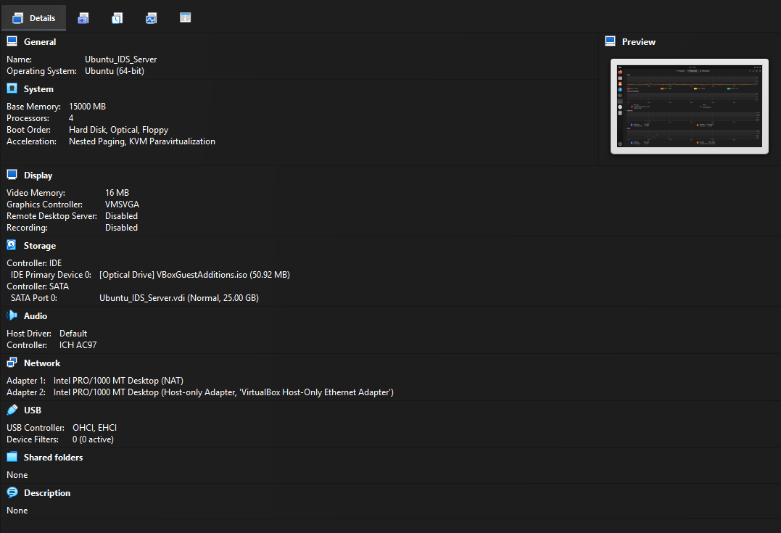
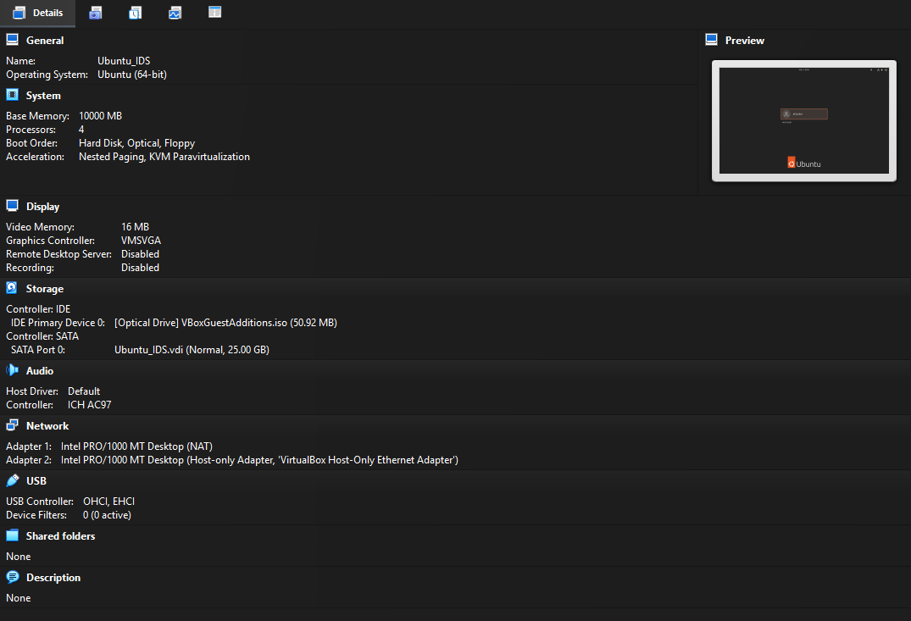

3.4 DFD Diagram of the Project
The Data Flow Diagram (DFD) represents how data flows through the SOC system. The architecture follows a sequential pipeline as implemented in the project.
Data Flow Steps
- Attacker VM
  - Generates malicious or test traffic using Nmap
  - Example: SYN scan and OS detection
- Suricata IDS Server
  - Monitors incoming network traffic
  - Detects suspicious activity based on rules
  - Generates alerts and log files
- Log Files
  - Logs stored in:
    - /var/log/suricata/fast.log
    - /var/log/suricata/eve.json
- Filebeat
  - Reads Suricata log files
  - Forwards logs securely to Elasticsearch
- Elasticsearch
  - Indexes and stores log data
  - Enables fast searching and querying
- Kibana Dashboard
  - Retrieves data from Elasticsearch
  - Displays alerts using dashboards and visualizations

DFD Flow Representation

Attacker VM: Generates malicious or test network traffic.
↓
Suricata IDS Server: Monitors incoming network traffic and detects suspicious activity and
Generates alert and log files based on detected threats.
↓
Filebeat: Collects Suricata log files and
Ships log data securely to Elasticsearch.
↓
Elasticsearch: Indexes and stores log data and
Enables fast searching and analysis.
↓
Kibana Dashboard: Visualizes data from Elasticsearch and
Provides dashboards, alerts, and security insights.

4. Design
The design phase of the project focuses on defining the architecture, modules, and working of the Virtual SOC Lab. It explains how different components are organized and how they interact with each other to achieve real-time threat detection and analysis.
The system is designed as a pipeline where network traffic flows from the attacker machine to the IDS server, and then through log forwarding and visualization components. Each module performs a specific function, ensuring a smooth and efficient workflow similar to a real-world Security Operations Centre (SOC).

4.1 Module Design and Organization
The entire project is divided into multiple modules based on functionality. Each module plays a critical role in the detection and analysis process.

Module 1: Attack Simulation
This module is responsible for generating network traffic that simulates real-world cyberattacks. The attacker machine uses tools such as Nmap to perform reconnaissance scans.
- Generates SYN scans and OS detection probes
- Simulates malicious traffic
- Helps in testing IDS detection capability

Module 2: Intrusion Detection System (Suricata)
This module monitors network traffic and detects suspicious activities.
- Captures packets from network interface (enp0s8)
- Applies detection rules (Emerging Threats ruleset)
- Generates alerts based on traffic patterns
- Produces log files such as fast.log and eve.json

Module 3: Log Collection and Forwarding (Filebeat)
This module is responsible for collecting logs generated by Suricata and forwarding them to Elasticsearch.
- Reads eve.json log file
- Processes and formats log data
- Sends logs securely to Elasticsearch
- Ensures continuous log flow

Module 4: Data Storage and Indexing (Elasticsearch)
This module stores and indexes the log data received from Filebeat.
- Indexes logs for fast search
- Stores structured data
- Enables querying and analysis
- Maintains a single-node cluster

Module 5: Visualization and Analysis (Kibana)
This module provides a graphical interface for monitoring and analyzing security events.
- Displays dashboards and charts
- Visualizes alerts and logs
- Helps in identifying attack patterns
- Provides real-time monitoring

4.2 Use Case and Class Diagrams
Use Case Description
The system involves interaction between the user (security analyst) and the SOC components.
Primary Use Cases:
- Monitor network traffic
- Detect suspicious activity
- View alerts in Kibana
- Analyze logs and events
- Validate detection results
Actors:
- Security Analyst (User)
- IDS System (Suricata)
- SIEM System (Elastic Stack)
The user interacts with Kibana to monitor alerts and analyze security events, while the backend components automatically process and forward data.

Class Diagram Description
The system can be logically divided into components:
- Attacker Class → Generates traffic
- Suricata Class → Detects threats
- Filebeat Class → Forwards logs
- Elasticsearch Class → Stores data
- Kibana Class → Visualizes data
These components interact sequentially, forming a pipeline architecture.

4.3 Algorithms
The project uses a combination of detection and data processing mechanisms rather than traditional computational algorithms.
1. Signature-Based Detection (Suricata Rules)
- Uses predefined rules (Emerging Threats ruleset)
- Matches network packets against known attack patterns
- Generates alerts when a match is found

2. Log Processing Algorithm (Filebeat)
- Reads log entries from eve.json
- Parses JSON data
- Converts logs into structured format
- Sends data to Elasticsearch

3. Indexing and Search Algorithm (Elasticsearch)
- Stores logs as indexed documents
- Enables fast search and filtering
- Supports real-time querying

4. Visualization Logic (Kibana)
- Retrieves indexed data
- Converts logs into graphs and charts
- Displays alerts in dashboards

The design ensures that all components work together efficiently, forming a complete SOC pipeline from attack simulation to threat visualization. This modular approach improves scalability, maintainability, and real-time monitoring capability of the system.

5. Implementation & Results
The implementation phase focuses on the practical setup and execution of the Virtual SOC Lab. In this project, all components such as Suricata IDS, Filebeat, Elasticsearch, and Kibana were successfully installed, configured, and integrated within a virtual environment.
The system was tested by simulating real-world attack scenarios using Nmap from the attacker machine. The generated traffic was analyzed by Suricata, and alerts were forwarded through the Elastic Stack for visualization. This validated the complete end-to-end pipeline of threat detection and analysis.

5.1 Explanation of Key Functions
The system performs several key functions to achieve real-time threat detection and monitoring:
- Traffic Monitoring:
Suricata continuously monitors network traffic through the configured interface (enp0s8).
- Threat Detection:
Suricata applies detection rules to identify suspicious activities such as SYN scans and OS detection attempts.
- Log Generation:
Detected events are recorded in log files such as fast.log and eve.json.
- Log Forwarding:
Filebeat reads the log files and forwards them to Elasticsearch.
- Data Storage:
Elasticsearch indexes and stores the logs for efficient searching and analysis.
- Visualization:
Kibana displays the logs in the form of dashboards, graphs, and alerts.

5.2 Method of Implementation
The implementation was carried out in a step-by-step manner as follows:
Step 1: Environment Setup
- Installed Oracle VirtualBox
- Created two virtual machines: IDS Server and Attacker Machine
- Configured Host-Only and NAT network adapters
Step 2: Suricata Installation and Configuration
- Installed Suricata on IDS server using package manager
- Enabled Emerging Threats (ET Open) ruleset
- Configured Suricata to monitor interface enp0s8
- Verified configuration using test command
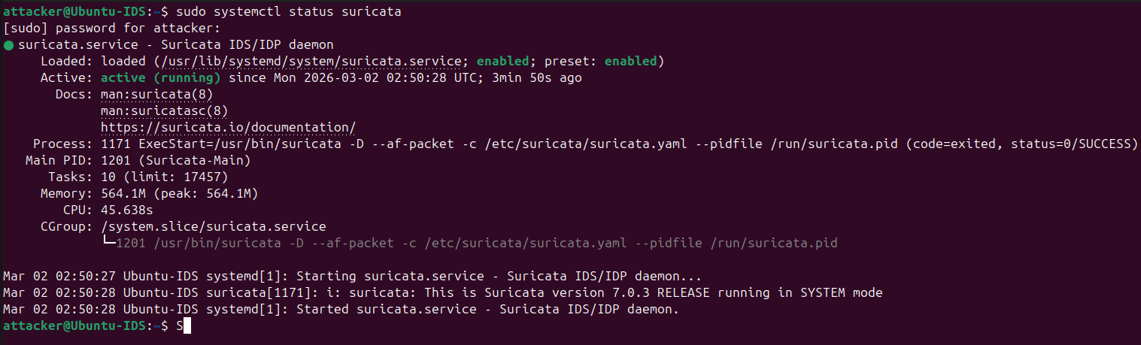
Step 3: Attack Simulation
- Installed Nmap on attacker machine
- Performed scans such as:
  - SYN Scan
  - OS Detection Scan
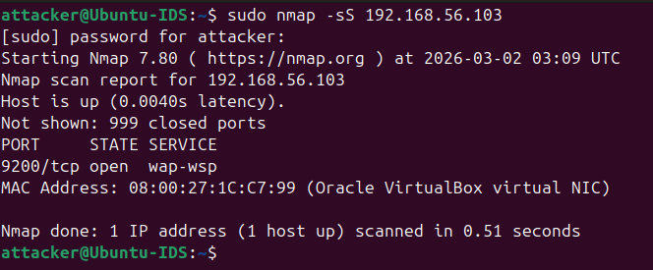
Step 4: Elastic Stack Setup
- Installed Elasticsearch and configured it as a single-node cluster
- Installed Kibana and connected it to Elasticsearch
- Verified access through web interface
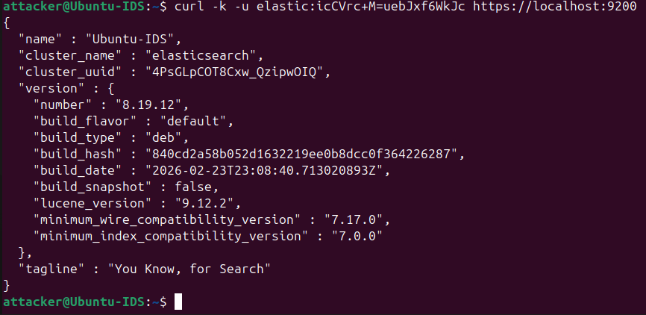

Step 5: Filebeat Configuration
- Enabled Suricata module in Filebeat
- Configured eve.json log path
- Started Filebeat service
- Verified log forwarding to Elasticsearch
Step 6: Data Visualization
- Created data view (filebeat-*) in Kibana
- Configured dashboards to display alerts
- Monitored real-time events
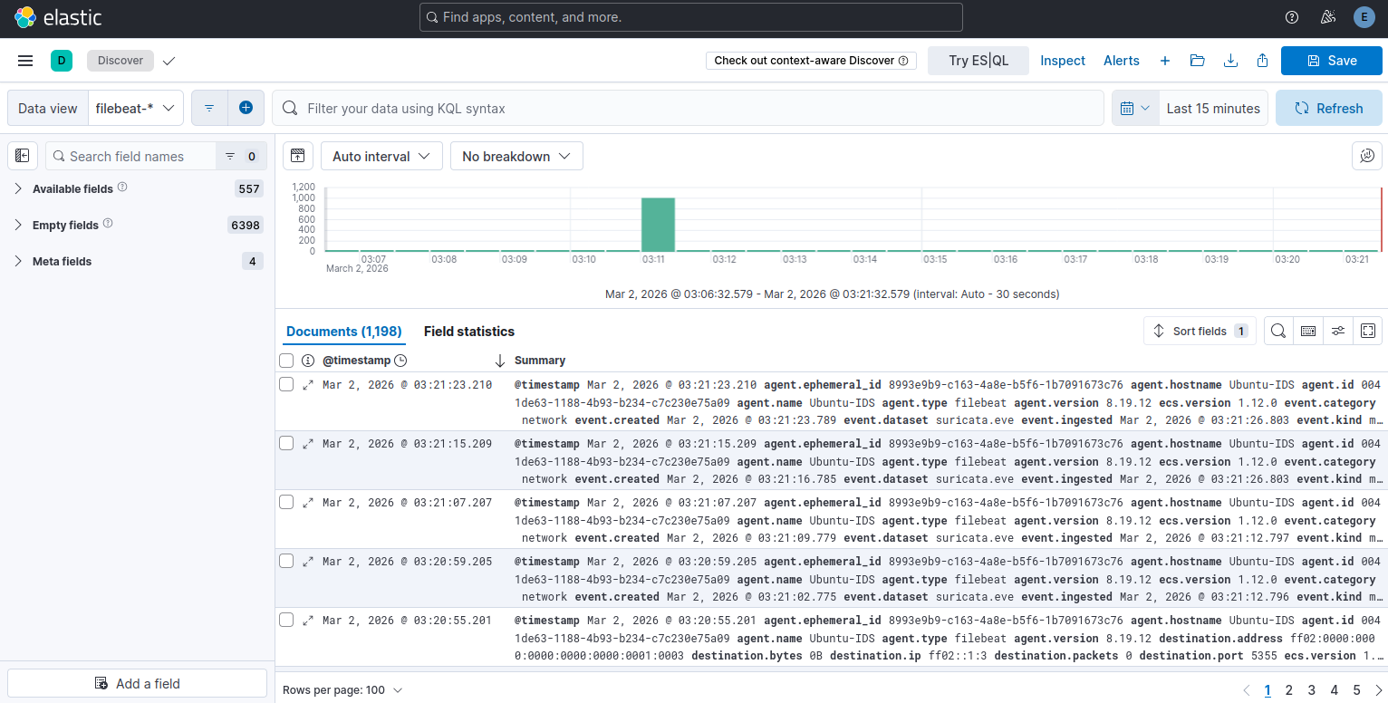
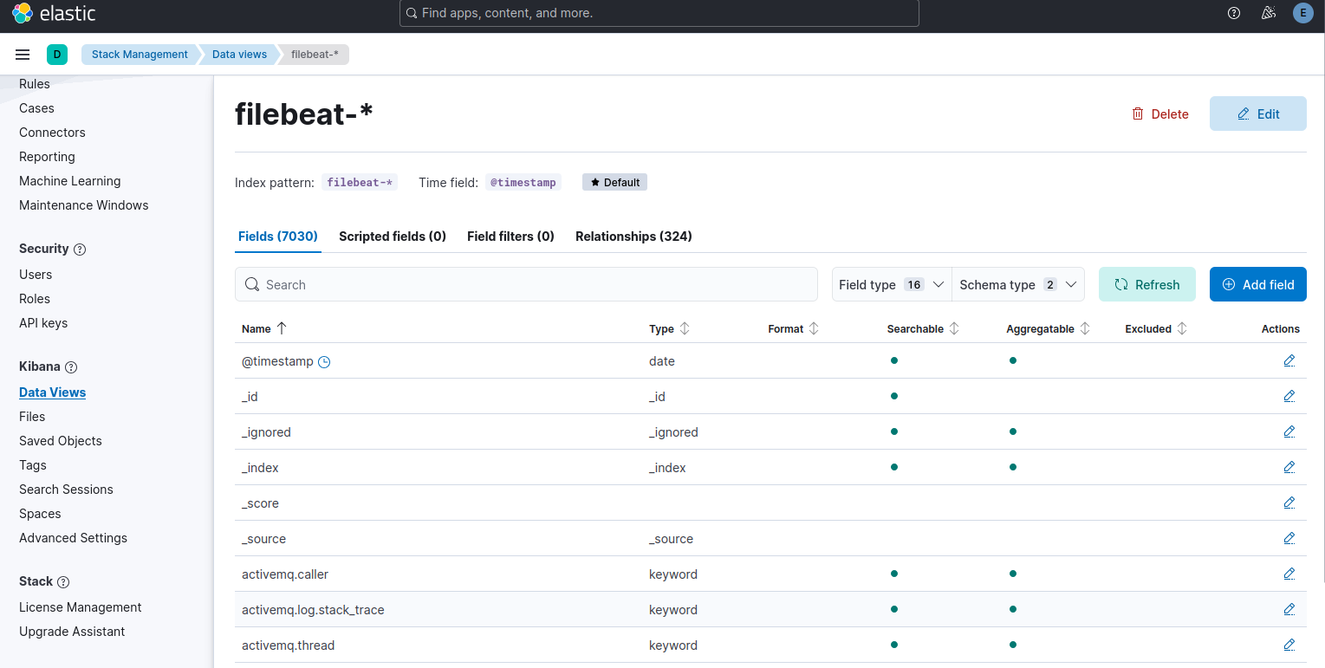

5.3 Output Screens
The following outputs were observed during the implementation:
- Suricata generated alerts in:
  - /var/log/suricata/fast.log
  - /var/log/suricata/eve.json
- Filebeat successfully forwarded logs to Elasticsearch
- Kibana displayed:
  - Alert dashboards
  - Event timelines
  - Threat detection graphs
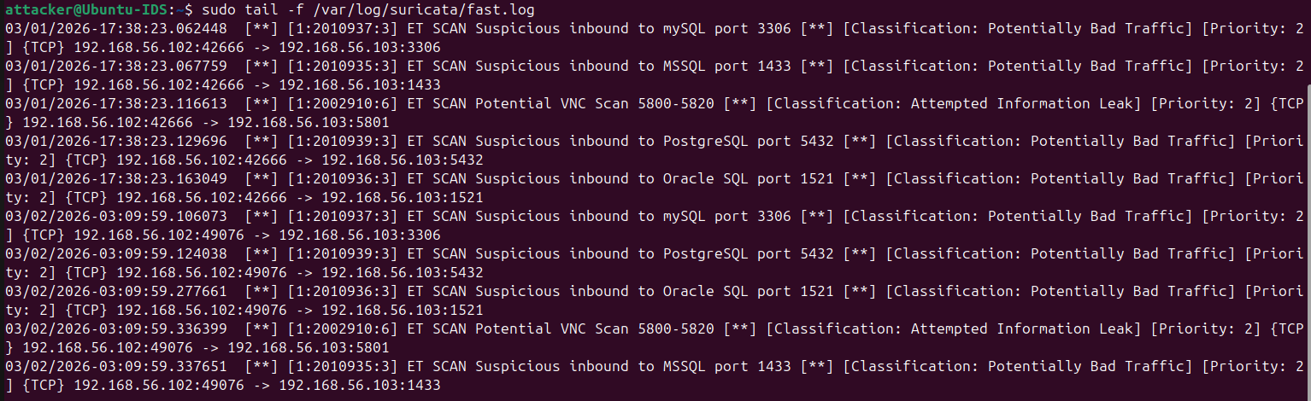
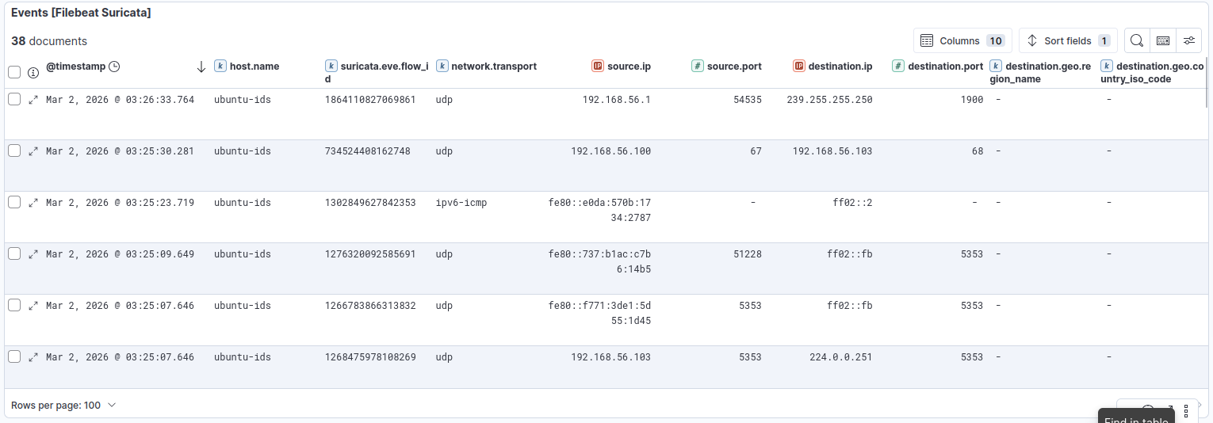
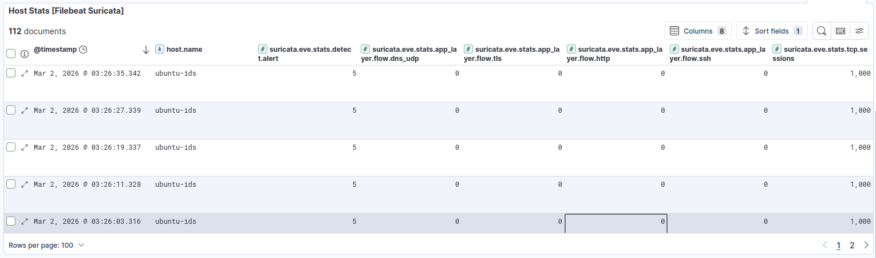
These outputs confirm that the system is functioning correctly and processing security events efficiently.

5.4 Result Analysis
The system successfully detected multiple reconnaissance activities generated from the attacker machine.
Observed Alerts:
- ET SCAN NMAP OS Detection Probe
- TCP SYN Scan patterns
- Reconnaissance activity alerts
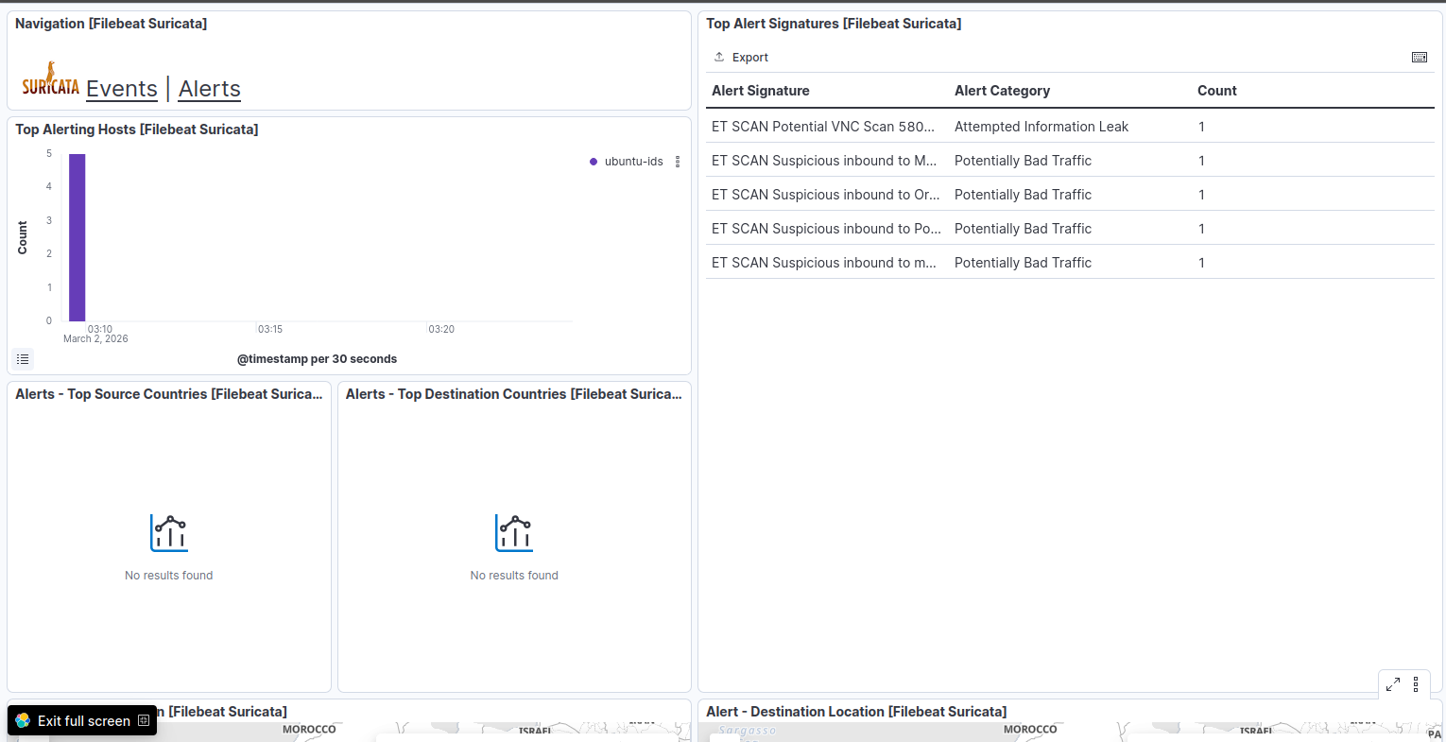
Analysis:
- All attack traffic was captured and analyzed by Suricata
- Alerts were generated in real-time
- Logs were forwarded without loss
- Elasticsearch indexed the events successfully
- Kibana visualized alerts clearly with timestamps and severity
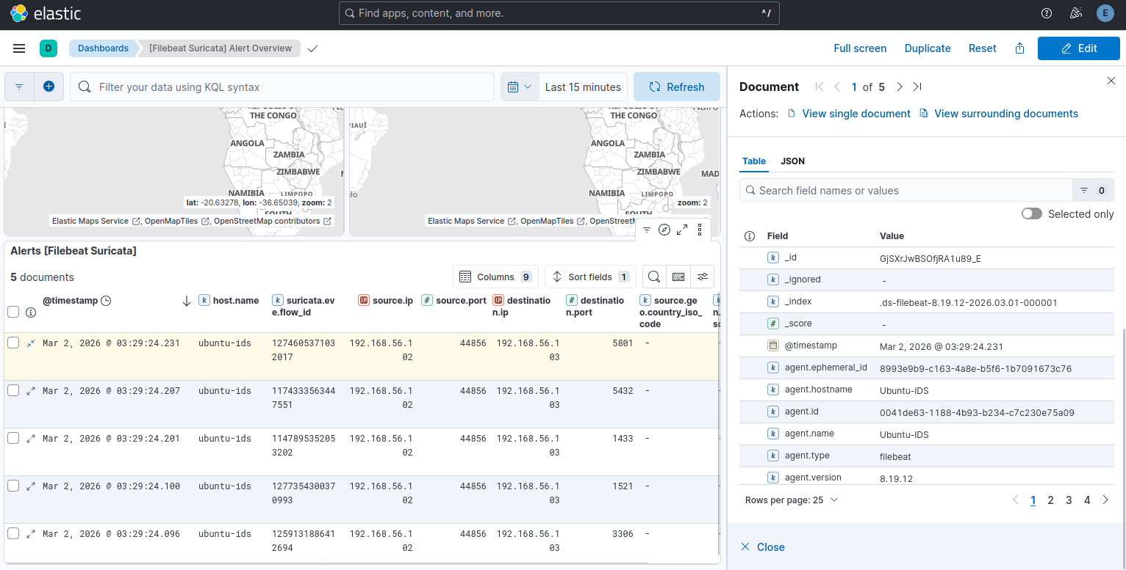
Validation of Pipeline:
- Attack executed using Nmap
- Suricata detected activity
- Logs generated in eve.json
- Filebeat forwarded logs
- Elasticsearch indexed data
- Kibana displayed alerts
The results confirm that the implemented SOC pipeline works effectively and provides real-time visibility into network threats.

6. Testing & Validation
Testing and validation are essential phases of the project to ensure that the system functions correctly and meets the desired objectives. In this project, testing was performed to verify the accuracy of threat detection, proper functioning of the log pipeline, and correct visualization of alerts in the SIEM system.
Different types of testing were carried out to evaluate the performance of each module in the Virtual SOC Lab. The system was tested under simulated attack conditions to ensure that it could detect and process malicious activities effectively.

6.1 Design of Test Cases and Scenarios
Various test cases were designed to validate the functionality of the system components. These test cases focused on attack simulation, detection accuracy, log forwarding, and visualization.
Test Case 1: Network Connectivity Test
- Objective: Verify communication between attacker and IDS server
- Method: Ping command and packet capture
- Expected Result: Successful connectivity between virtual machines

Test Case 2: Attack Simulation Test
- Objective: Generate malicious traffic
- Method: Execute Nmap SYN scan and OS detection scan
- Expected Result: Traffic generated and received by IDS

Test Case 3: Intrusion Detection Test
- Objective: Verify Suricata detection capability
- Method: Monitor logs after attack simulation
- Expected Result: Alerts generated for Nmap scans

Test Case 4: Log Generation Test
- Objective: Ensure logs are properly created
- Method: Check fast.log and eve.json files
- Expected Result: Logs updated with detected events

Test Case 5: Log Forwarding Test
- Objective: Verify Filebeat functionality
- Method: Test output and monitor Elasticsearch
- Expected Result: Logs successfully forwarded

Test Case 6: Data Indexing Test
- Objective: Confirm Elasticsearch indexing
- Method: Query Elasticsearch
- Expected Result: Events stored and searchable

Test Case 7: Visualization Test
- Objective: Verify Kibana dashboards
- Method: Access Kibana and view dashboards
- Expected Result: Alerts displayed correctly

Test Case 8: End-to-End Pipeline Test
- Objective: Validate complete workflow
- Method: Perform attack and track data flow
- Expected Result: Successful detection → forwarding → visualization

6.2 Validation
The validation process confirms that the system meets the project objectives and performs as expected under test conditions.
During validation, the following observations were made:
- The attacker machine successfully generated reconnaissance traffic
- Suricata detected suspicious activities accurately using predefined rules
- Log files (eve.json and fast.log) were updated in real-time
- Filebeat forwarded logs to Elasticsearch without data loss
- Elasticsearch indexed the logs efficiently
- Kibana displayed alerts and visualizations correctly
The system demonstrated a complete and functional SOC pipeline, validating the effectiveness of integration between Suricata IDS and Elastic SIEM Stack.
Overall, the testing and validation results confirm that the system is reliable, accurate, and capable of detecting and analyzing network threats in a virtual environment.

7. Conclusion & Future Scope
The project “Virtual SOC Lab: Suricata IDS Integrated with Elastic SIEM Stack” successfully demonstrates the design and implementation of a functional Security Operations Centre (SOC) environment using open-source tools. The system was able to monitor network traffic, detect suspicious activities, and visualize security events in real time.
Through this project, Suricata was effectively deployed as a Network Intrusion Detection System (IDS) to analyze incoming network traffic and identify potential threats such as reconnaissance scans. The integration with the Elastic Stack enabled centralized log management, efficient data indexing, and powerful visualization through Kibana dashboards.
The end-to-end pipeline—from attack simulation using Nmap, to detection by Suricata, log forwarding via Filebeat, indexing in Elasticsearch, and visualization in Kibana—was successfully implemented and validated. The results confirmed that the system can detect and display security alerts accurately and efficiently.
This project provides a practical understanding of SOC operations and highlights the importance of integrating IDS with SIEM solutions for effective cybersecurity monitoring. It also demonstrates how open-source tools can be used to build a cost-effective and scalable security solution.

Future Scope
Although the current system performs effectively, several enhancements can be implemented to improve its capabilities:
- Integration with Additional Tools:
Tools like Zeek and Wazuh can be added for deeper network and host-based analysis.
- Automated Incident Response:
Implement automation mechanisms to respond to detected threats without manual intervention.
- Machine Learning-Based Detection:
Incorporate anomaly detection techniques to identify unknown or zero-day attacks.
- Advanced Dashboard Creation:
Develop customized dashboards in Kibana for better visualization and reporting.
- Alerting Mechanisms:
Configure email or SMS alerts for real-time notifications of critical threats.
- Cloud Deployment:
Deploy the SOC environment on cloud platforms for scalability and remote access.
- Docker-Based Deployment:
Use containerization for easier deployment and management of components.
With these enhancements, the system can be transformed into a more advanced and enterprise-level SOC solution capable of handling complex cybersecurity challenges.

8. Bibliography
- Suricata Documentation, Open Information Security Foundation, Available: https://suricata.io/documentation
- Elastic Stack Documentation (Elasticsearch, Kibana, Filebeat), Elastic, Available: https://www.elastic.co/guide
- Nmap Reference Guide, Insecure.Org, Available: https://nmap.org/book
- OISF, “Suricata User Guide and Rule Management Documentation,” Open Information Security Foundation
- Elastic, “Elasticsearch: The Definitive Guide,” Elastic Stack Documentation
- Elastic, “Kibana User Guide,” Elastic Stack Visualization Documentation
- Elastic, “Filebeat Reference Manual,” Elastic Log Forwarding Documentation
- Scarfone, K., and Mell, P., “Guide to Intrusion Detection and Prevention Systems (IDPS),” National Institute of Standards and Technology (NIST)
- Behl, A., Cybersecurity and Cyberwar: What Everyone Needs to Know, Oxford University Press
- Stallings, W., Network Security Essentials: Applications and Standards, Pearson
- Northcutt, S., Network Intrusion Detection, New Riders Publishing
- MITRE ATT&CK Framework, Available: https://attack.mitre.org
- Ubuntu Documentation, Canonical Ltd., Available: https://ubuntu.com
- Oracle VirtualBox Documentation, Available: https://www.virtualbox.org
- Research Papers on Intrusion Detection Systems and SIEM Technologies (various IEEE and Springer publications)

